Staging environment

🗂️ What Is Development environment?
# Source: AI Source: Provided by: [Data Path: Persons Table -> ID Column: 1, Name_En Column: Motasem Essam] -> From: [ChatGPT] on [1/26/2026]
A staging environment is a pre-production environment used to test an application as if it were live, but without real users.
Think of it as the dress rehearsal before the actual performance.

What a staging environment is for
# Source: AI Source: Provided by: [Data Path: Persons Table -> ID Column: 1, Name_En Column: Motasem Essam] -> From: [ChatGPT] on [1/26/2026]
Staging is used to:
- Catch bugs before production
- Test integrations (APIs, payments, emails, auth)
- Validate configurations
- Get approvals from QA, product, or clients

Key characteristics
# Source: AI Source: Provided by: [Data Path: Persons Table -> ID Column: 1, Name_En Column: Motasem Essam] -> From: [ChatGPT] on [1/26/2026]
A staging environment usually:
- 🧱 Closely mirrors production (same OS, versions, infrastructure)
- 🗄️ Uses production-like data (often anonymized)
- 🔐 Uses real configurations but safe credentials
- 🚫 No real users
- 🧪 Used for manual & automated testing

Example configuration
# Source: AI Source: Provided by: [Data Path: Persons Table -> ID Column: 1, Name_En Column: Motasem Essam] -> From: [ChatGPT] on [1/26/2026]
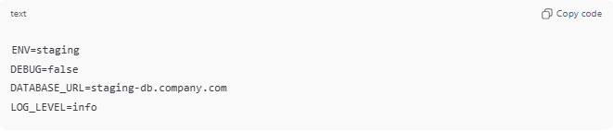
ENV=staging
DEBUG=false
DATABASE_URL=staging-db.company.com
LOG_LEVEL=info

How it differs from development
# Source: AI Source: Provided by: [Data Path: Persons Table -> ID Column: 1, Name_En Column: Motasem Essam] -> From: [ChatGPT] on [1/26/2026]
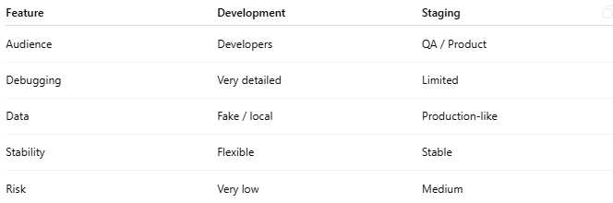
Feature | Development | Staging
Audience | Developers | QA / Product
Debugging | Very detailed | Limited
Data | Fake / local | Production-like
Stability | Flexible | Stable
Risk | Very low | Medium

How it fits in the workflow
# Source: AI Source: Provided by: [Data Path: Persons Table -> ID Column: 1, Name_En Column: Motasem Essam] -> From: [ChatGPT] on [1/26/2026]
- Development – build the feature
- Staging – test it in real conditions
- Production – release to users

Real-world analogy
# Source: AI Source: Provided by: [Data Path: Persons Table -> ID Column: 1, Name_En Column: Motasem Essam] -> From: [ChatGPT] on [1/26/2026]
It’s like:
A full dress rehearsal on the actual stage, with lights and sound, but no audience.
If you want, I can explain production environment, UAT, or show a CI/CD pipeline example where staging fits in.

Testing environment vs Staging environment
# Source: AI Source: Provided by: [Data Path: Persons Table -> ID Column: 1, Name_En Column: Motasem Essam] -> From: [ChatGPT] on [1/26/2026]
testing and staging environments are related, but not the same.
They’re often confused because some teams combine them, but conceptually they serve different purposes.

Testing environment
# Source: AI Source: Provided by: [Data Path: Persons Table -> ID Column: 1, Name_En Column: Motasem Essam] -> From: [ChatGPT] on [1/26/2026]
Purpose: Verify correctness
Used mainly for:
- Automated tests (unit, integration, regression)
- QA testing
- Finding bugs early
Typical traits:
- May not fully match production
- Uses mock or test data
- Debugging tools enabled
- Can be unstable (reset often)

Staging environment
# Source: AI Source: Provided by: [Data Path: Persons Table -> ID Column: 1, Name_En Column: Motasem Essam] -> From: [ChatGPT] on [1/26/2026]
Purpose: Verify readiness for release
Used mainly for:
- Final validation before production
- Configuration & infrastructure checks
- Performance and integration testing
- Stakeholder approval
Typical traits:
- Almost identical to production
- Production-like data
- Limited debugging
- Stable and release-ready

Side-by-side comparison
# Source: AI Source: Provided by: [Data Path: Persons Table -> ID Column: 1, Name_En Column: Motasem Essam] -> From: [ChatGPT] on [1/26/2026]
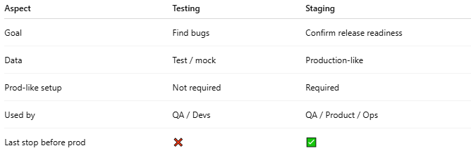
Aspect | Testing | Staging
Goal | Find bugs | Confirm release readiness
Data | Test / mock | Production-like
Prod-like setup | Not required | Required
Used by | QA / Devs | QA / Product / Ops
Last stop before prod | ❌ | ✅

Why people mix them up
# Source: AI Source: Provided by: [Data Path: Persons Table -> ID Column: 1, Name_En Column: Motasem Essam] -> From: [ChatGPT] on [1/26/2026]
- Small teams often use one environment and call it both
- Some companies rename them:
  - Test = QA
  - Staging = Pre-prod
So you might hear:
“We test in staging”
…which is practically true, but technically simplified.

Best-practice flow (ideal world)
# Source: AI Source: Provided by: [Data Path: Persons Table -> ID Column: 1, Name_En Column: Motasem Essam] -> From: [ChatGPT] on [1/26/2026]
Development → Testing → Staging → Production

